Appendix 4

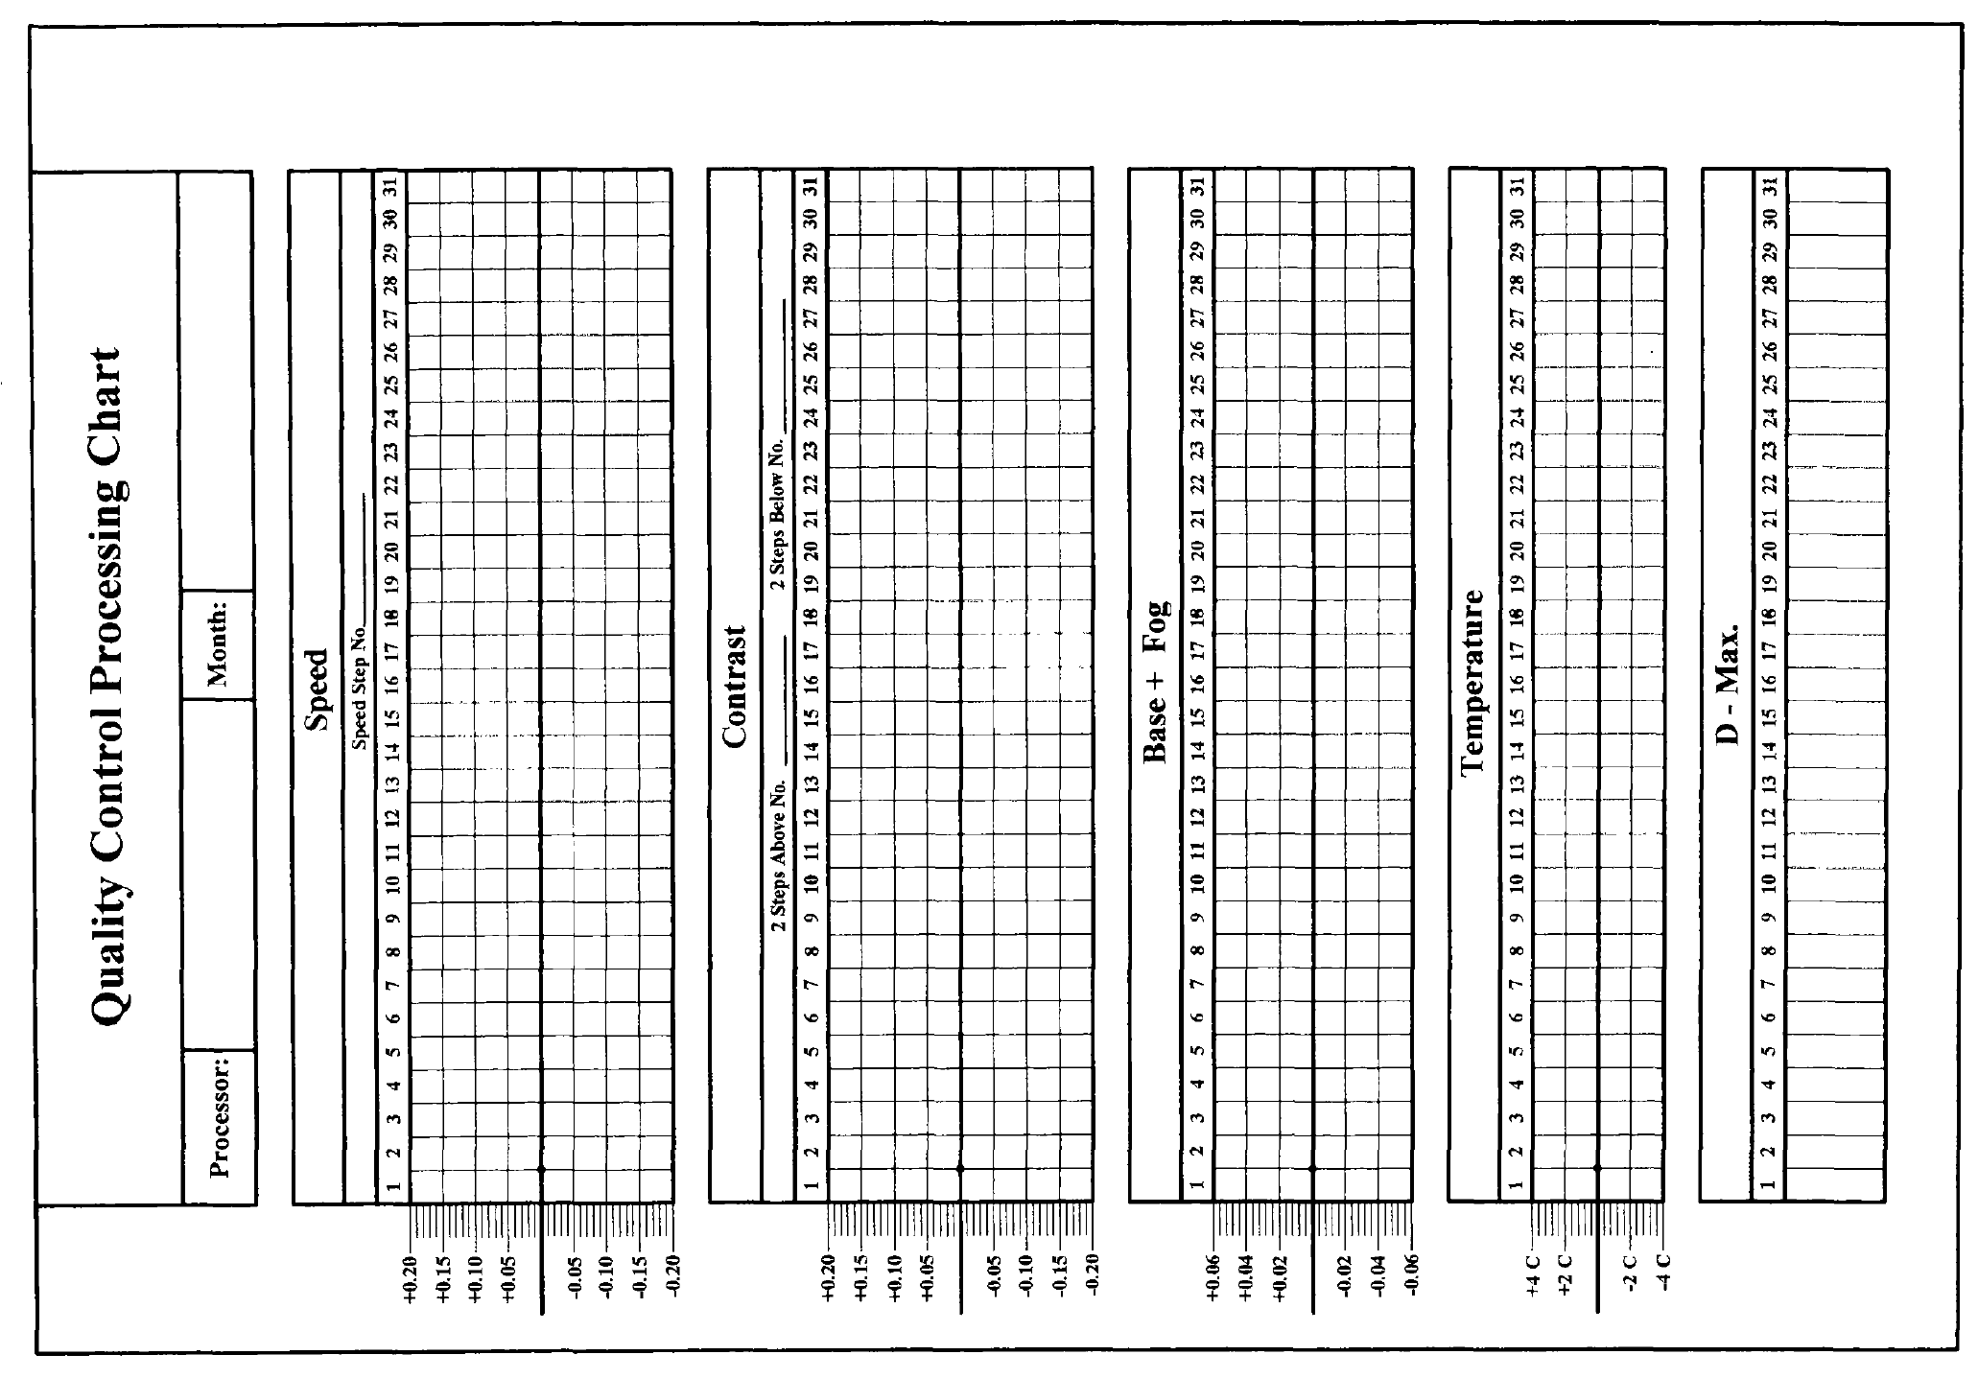

Source: World Health Organisation QA Workbook (1)

